**I. Equation** ________________________________________________________________

___________________________________________________________________________

**Inequality** __________________________________________________________________

___________________________________________________________________________

**Inequality symbols:**

< LESS THAN – Points to the left of a number line

Solution is less than a given number

≤ LESS THAN or EQUAL TO – Points to the left of a number line

Solution is less than a given number or equal to a

given number

> GREATER THAN – Points to the right of a number line.

Solution is greater than a given number

≥ GREATER THAN or EQUAL TO – Points to the left of a number line

Solution is less than a given number or equal to a

given number

**II.** Use a number line to represent the solutions to an inequality. Symbols and shading are used to show the solutions on that number line.

**➀** If the inequality uses > < then the number line uses ( ) parentheses.

**➁** If the inequality uses **≥ ≤** then the number line uses [ ] square brackets.

Solutions to inequalities can be written in two symbolic forms:

**➀** Set-builder notation looks similar to the solution to the problem except the solution is

placed inside braces { }

**➁** Interval notation looks similar to the number line and uses the same symbols ( ) [ ]

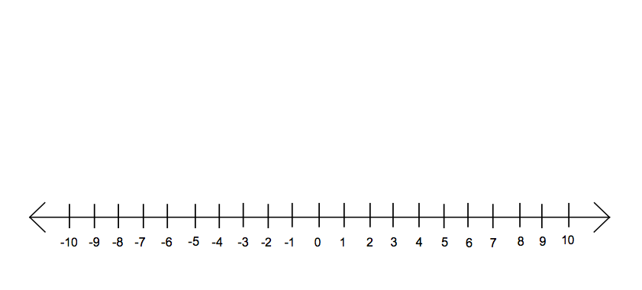**EX.** x ≤ 6

set-builder notation interval notation



**EX.** y > -7

set-builder notation interval notation



**EX.** -5 **≤** x < 4

set-builder notation interval notation

**III.** Solve inequalities using the same rules for solving equations.

Hint: put your variable (letter) on the left side every time.

**EXAMPLE:** Solve the following inequalities, graph solution on a number line, and write the solution in interval notation.



4x + 1 **≥** 21

****-2x <12

$$-\frac{3}{4}x <3$$

$$\frac{3x - 5}{-4} ≥5$$







-3(x – 6) **≥** 2x – 2

**IV.** Three-part inequalities is when you have three parts with the variable in the middle.

Solve then the same way by getting the letter by itself but now you must do step to all three parts. You work inside…out.

**EXAMPLE:** Solve the following inequalities, graph solution on a number line, and write the solution in interval notation.



-4 ≤ x + 3 ≤ 10



$-3 < \frac{2x + 2}{4} ≤ 5$

Beth scored 92 and 86 on her first two tests. What does she need to make on her third test to keep an average of 90 or better in her class?

Katrina has scores of 88, 92, and 78 after three tests. Her final exam counts as two test scores. What does she need to make on her final exam to have an average of 80 or greater in her class?